Online CESR/CEGPR Application – User Guide

Contents

Contents

Introduction 2
Why are we making these changes? 2
Electronic evidence 2
The online application: a step-by-step guide 3
First steps 3
Completing the online application 7
Submitting additional evidence 20
CESR/CEGPR Review applications 26
Making a Review application 26
Review applications: providing additional evidence 36
What can I upload? 42
Handy hints for your CESR/CEGPR application 43
Contacting us 44
Annex 1 – Evidence statuses 45
Annex 2 – Troubleshooting 46
Annex 3 – Documentary evidence 49
Index – useful links 55

Introduction
This guide has been produced to aide applicants applying for the Certificate of Eligibility for Specialist or GP Registration (CESR/CEGPR) via GMC Online.
From 6 November 2018, doctors applying for a CESR/CEGPR have the option to submit evidence electronically. This guide will walk through each stage of the online application, including advice on troubleshooting and the types of evidence that can be uploaded

Why are we making these changes?
The GMC’s Education and Standards Directorate produced new standards for specialty training curricula development, requiring all Royal Colleges and Faculties to update their specialty curricula to include the Generic Professional Capabilities framework (GPCs) by the end of 2020.
CESR/CEGPR applications are assessed against these specialty curricula; therefore we need to ensure that the application reflects these changes.
Prior to 6 November 2018, the online application was structured against the four domains of Good Medical Practice. With the introduction of GPCs, the curricula will be structured in different ways, for example learning outcomes or area of competence. All specialty training curricula will be updated at different times over the next few years.
In response to this, we’ve developed a new online application for CESR and CEGPR applications.

Electronic evidence
Feedback we’ve received from previous and prospective applicants highlighted the desire to provide evidence electronically. The changes we’ve made to the online application have given us the opportunity to introduce this functionality and enable applicants to upload their evidence electronically.
Electronic evidence can be uploaded for each of the different evidence sections of the CESR/CEGPR application. The online application remains open for 12 months, meaning that it can be used as a portfolio to gather evidence against each of the different sections.
The new online application allows Applications Advisers to share guidance with applicant electronically through GMC Online, making the application process faster and more secure.

The online application: a step-by-step guide

First steps
Before you can begin your CESR/CEGPR application, you must have a GMC Online account. You can register for a GMC Online account through the GMC website.
If you already have a GMC Online account, you will need to log on to this. If you do not have a GMC Online account, please follow the guidance below.

I’m already registered with the GMC
If you already hold GMC registration, you will need to follow the below steps in order to begin your CESR/CEGPR application:
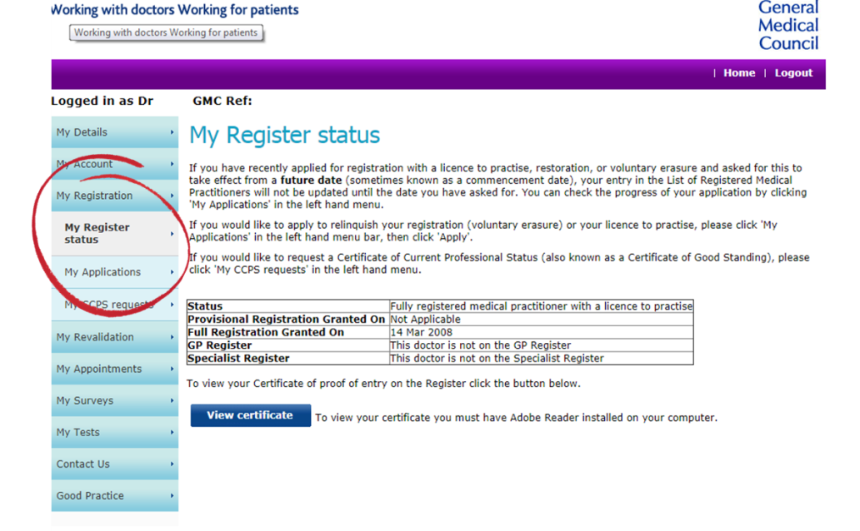
- Once on your GMC Online homepage, click the ‘My Registration’ tab on the left side of the screen.
This will bring up a list of three options – you’ll need to select ‘My Applications’
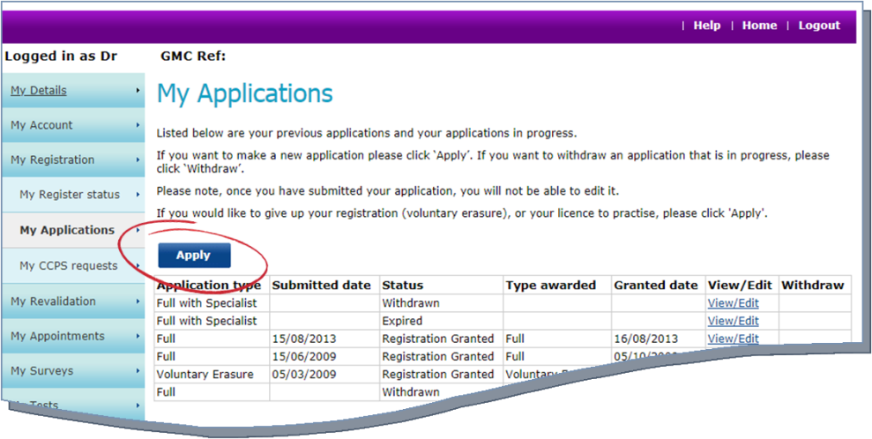
- The ‘My Applications’ page will bring up a list of your past and present applications with the GMC. To open a new application (e.g. CESR/CEGPR) click the ‘Apply’ button
- You will be prompted to read important information and guidance – once you have done this, select ‘Continue with application’
- You’ll be asked a series of questions regarding your GMC registration. You should review these carefully, selecting the relevant answer. You’ll then be asked if you have an EC right – you should read the EC rights factsheet if you’re unsure about this
- You’ll then be asked if you want to apply for entry onto the Specialist or GP Register – you’ll need to select ‘Yes’ for this
- Following this, you’ll be asked a series of questions regarding your eligibility for CESR/CEGPR – you should select the relevant answer. If you’re unsure about your eligibility, please review our guidance
- If you meet the eligibility requirements, you’ll then be given the option to apply for either:
      - Entry onto the Specialist Register with a CESR
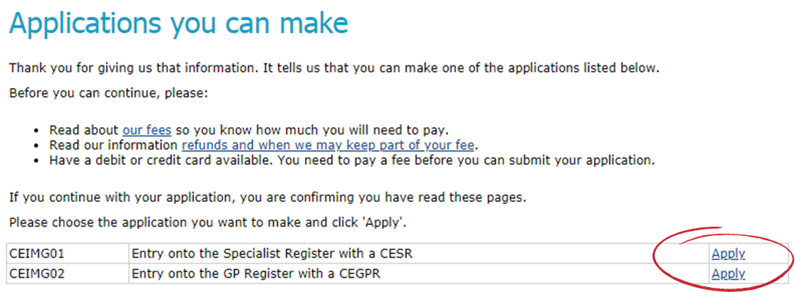
      - Entry onto the GP Register with a CEGPR
- Select ‘Apply’ for the relevant application
You’ll now need to follow the guidance on completing the online CESR/CEGPR application.

I am not registered with the GMC
If you do not hold GMC registration, you will need to follow the below steps in order to begin our CESR/CEGPR application:
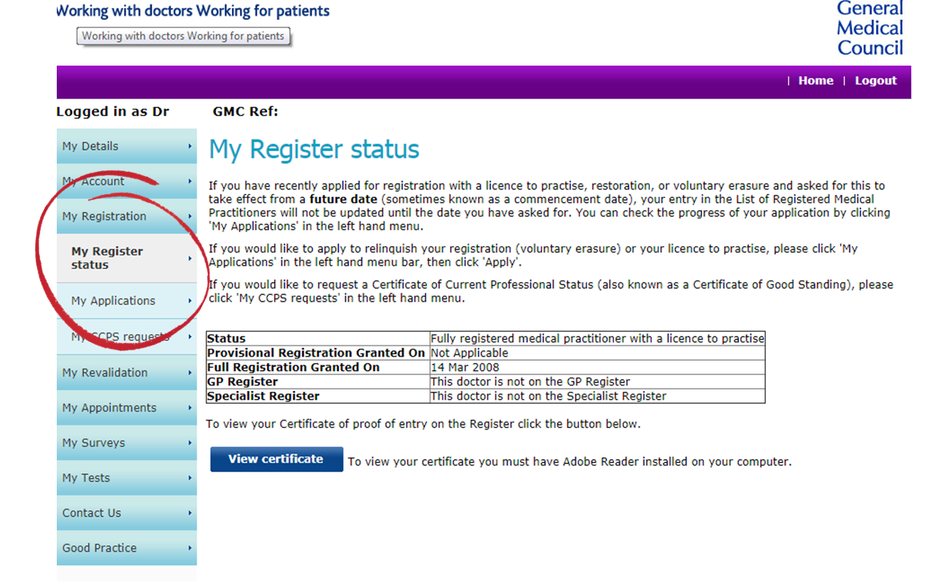
- Once on your GMC Online homepage, click the ‘My Registration’ tab on the left side of the screen.
This will bring up a list of three options – you’ll need to select ‘My Applications’
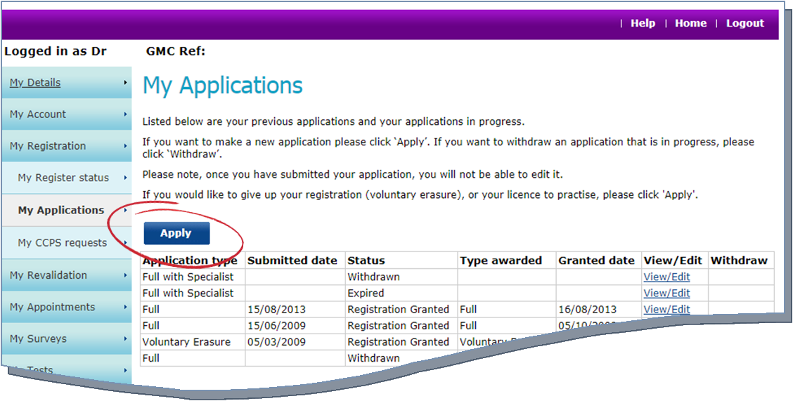
- The ‘My Applications’ page will bring up a list of your past and present applications with the GMC. To open a new application (e.g. CESR/CEGPR) click the ‘Apply’ button
- You will be prompted to read important information and guidance – once you have done this, select ‘Continue with application’
- You’ll then be asked if you have an EC right – you should read the EC rights factsheet if you’re unsure about this
- If you selected ‘No’ to the above, you’ll be asked if you want to apply for entry onto the Specialist or GP Register – you’ll need to select ‘Yes’ for this
- Following this, you’ll be asked a series of questions regarding you eligibility for CESR/CEGPR. You should select the relevant answer. If you’re unsure about your eligibility for CESR/CEGPR, please review our guidance
- If you meet the eligibility requirements, you’ll then be given the option to apply for either:
      - Full registration and entry onto the Specialist Register with a CESR
      - Full registration and entry onto the GP Register with a CEGPR
- Select ‘Apply’ for the relevant application
You’ll now need to follow the guidance on completing the online CESR/CEGPR application.

Completing the online application
The below steps will guide you through each section of the CESR/CEGPR online application.

Step 1 – specialty details
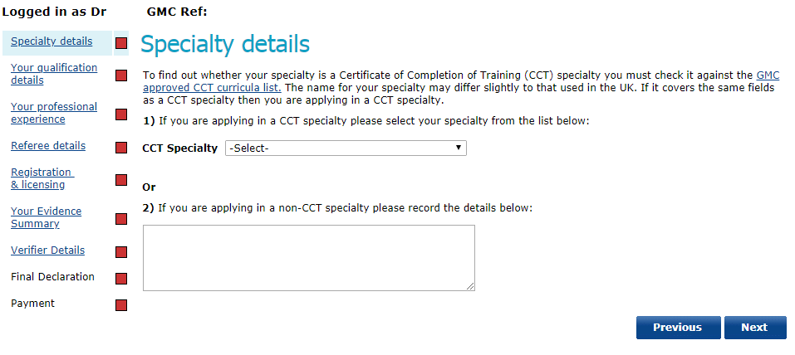
- You will need to select the relevant CCT specialty that you’re applying in from the drop down list. If you’re applying in a non-CCT specialty, you’ll need to record the details in the specified box.
If you’re unsure whether your specialty is an approved CCT specialty, please refer to the GMC approved CCT curricula list.
- Once you have added the specialty, you will be asked to confirm that the specialty details are correct.
Note: once confirmed, it will not be possible to change your specialty without withdrawing the whole application and starting again
If you’re applying for a CESR/CEGPR with full GMC registration you will need to complete the following additional steps:
- You’ll be asked to confirm your name details
- If your name is different to the one on your PMQ, you should select ‘Yes’ – you will then need to provide further details

Step 2 – qualification details and professional experience
You’ll need to record all of your relevant qualifications – this should include:
- Primary medical qualification (PMQ)
- Postgraduate specialist medical qualifications (SMQ)
- Other relevant qualifications
For each qualification that you list, you must include:
- Full title of the qualification
- University or awarding body, including country
- Award date
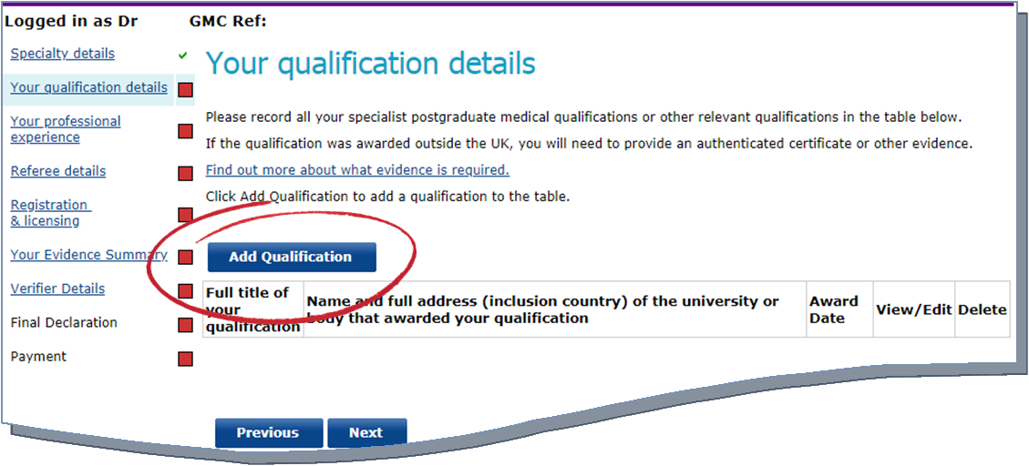
- To add a qualification, select the ‘Add Qualification’ button as highlighted below
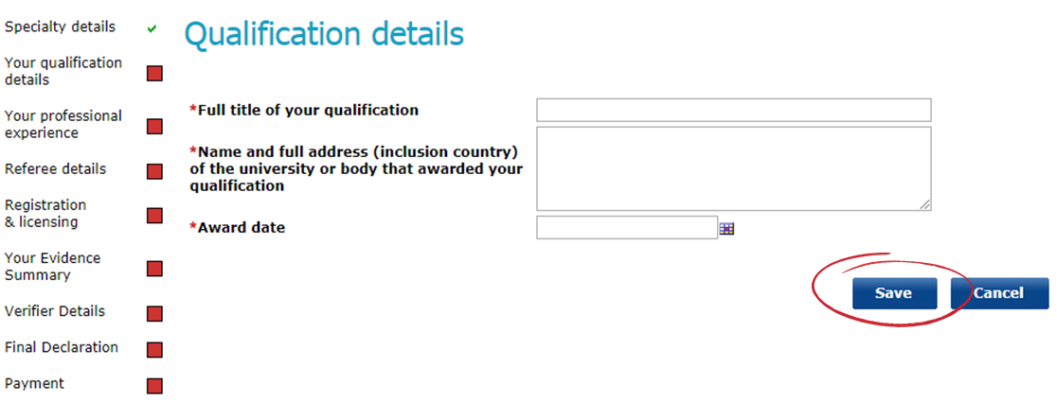
- This will take you to a screen where you’ll need to enter the details of each qualification.
Note: each field on this screen must be completed
- After adding the qualification details, click ‘Save’. This will then take you back to the previous screen where you can continue to record additional qualifications
- Once you have added all your qualifications, click ‘Next’
- You’ll need to enter the details of your work history (professional experience). You should provide details of all the posts you’ve held since you were awarded your PMQ.
Note: you should start with the most recent and work backwards. You’ll also need to account for any periods where you were unemployed or not engaged in medical practice. Further guidance on listing your professional experience can be found here.
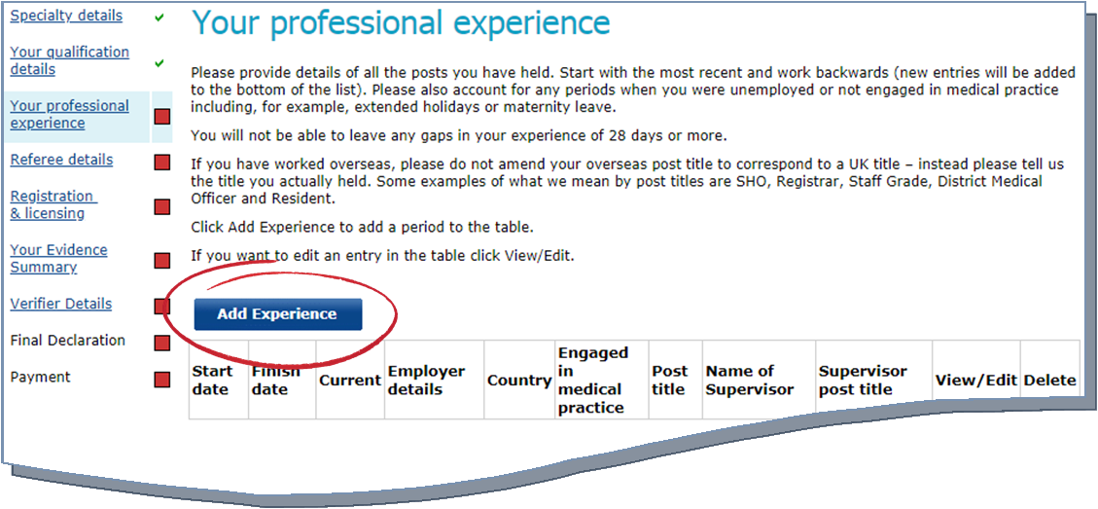
- To add details of your work history, you’ll need to click ‘Add Experience’, as highlighted below
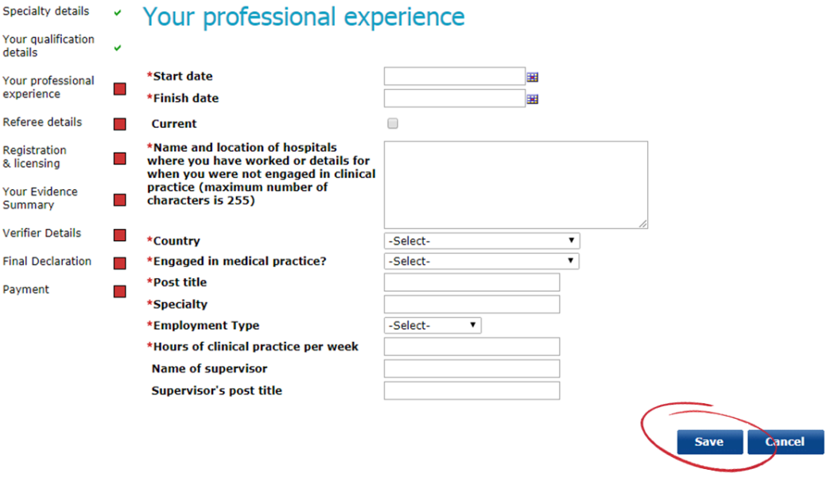
- This will then take you to a screen where you’ll need to enter the details of each of the individual posts you have undertaken. Each field on this screen must be completed
- After adding the post details, click ‘Save’. This will then take you back to the previous screen where you can continue to record your professional experience
- If you want to edit an entry after recording it, select the ‘View/Edit’ option next to each entry
- Once you have added your work history, click ‘Next’

Step 3 – adding details of your referees
As part of your CESR/CEGPR application, you must nominate a minimum of four referees. For advice on selecting your referees, you should refer to our guidance.
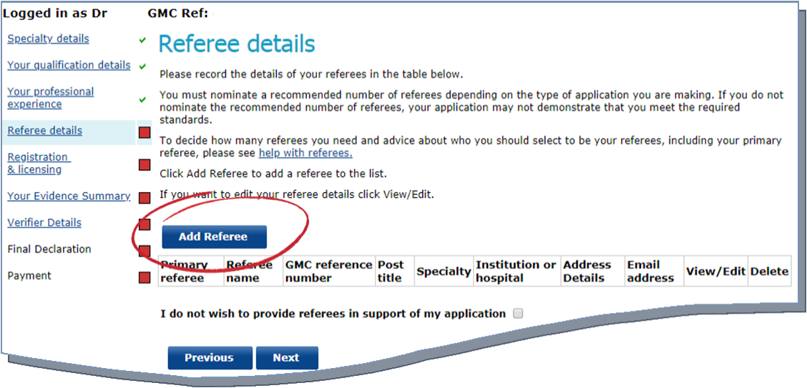
- To add a referee, select ‘Add referee’
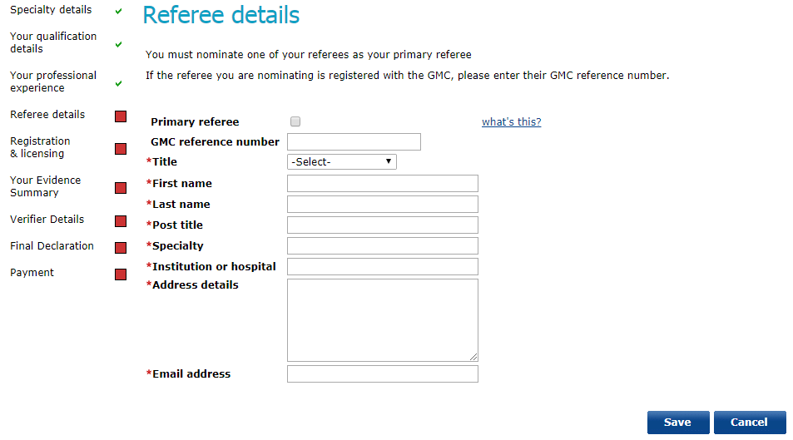
- This will take you to a screen where you’ll need to enter the details of each of your nominated referees. Each field on this screen must be completed
Note: You must select whether the referee is your primary referee – for further help refer to our guidance. If your referee has GMC registration, you must provide their GMC reference number
- After adding the referee details, click ‘Save’ – this will then take you back to the previous scree where you can continue to add your nominated referees
- If you want to edit an entry after recording it, select the ‘View/Edit’ option next to each entry
- Once you have added your nominated referees, click ‘Next’

Step 4 – registration and licensing history
You’ll need to add the details of all medical regulatory authorities that you’ve held registration with in the last five years
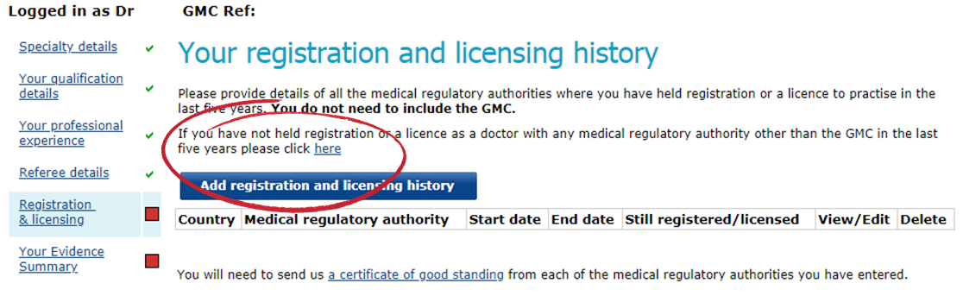
- To add the details of your registration and licensing, click the ‘Add registration…’ button
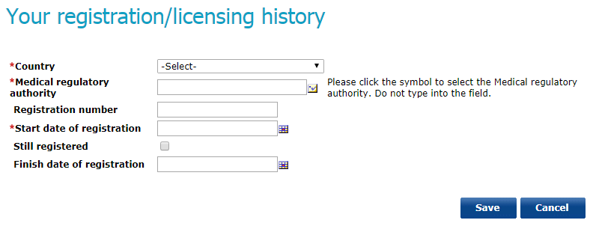
- This will take you to a screen where you’ll need to enter the details of your registration / licensing history. Each field on this screen must be completed
Note: you do not need to include your registration with the GMC

Step 5 – your evidence summary
The new online application for CESR/CEGPR will allow you to upload your evidence electronically.
The evidence summary page contains a table which outlines:
- The areas of competence you need to demonstrate
- A summary of what you need to demonstrate
- Evidence we recommend you provide
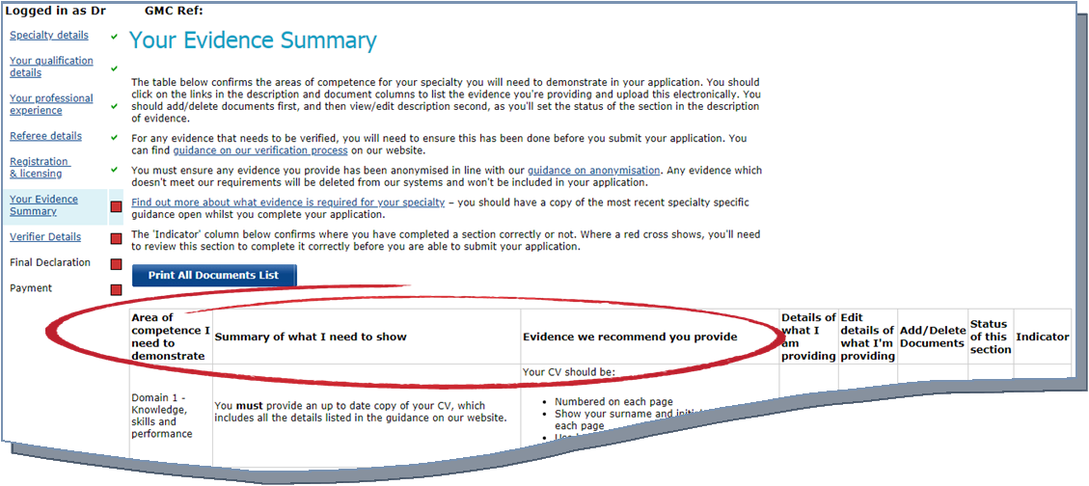
These three columns mirror the Specialty Specific Guidance (SSG) for your chosen specialty.
The table on the evidence summary page will also display the details of the documents you’re providing for each area of the CESR/CEGPR application, and a status for each section.
In order to progress your application, you must ensure that you’ve selected a relevant status for each evidence section. A full list and description of the evidence statuses can be found in Annex 1.
You must also ensure that you’ve provided an appropriate description for each document you’ve uploaded. Please refer to Annex 3 for further guidance.
You cannot progress the application until all sections have been completed. If a section of the evidence summary remains incomplete you’ll receive a specific error message – further information on error messages / troubleshooting can be found in Annex 2.

To add your documentary evidence electronically, follow the below steps:
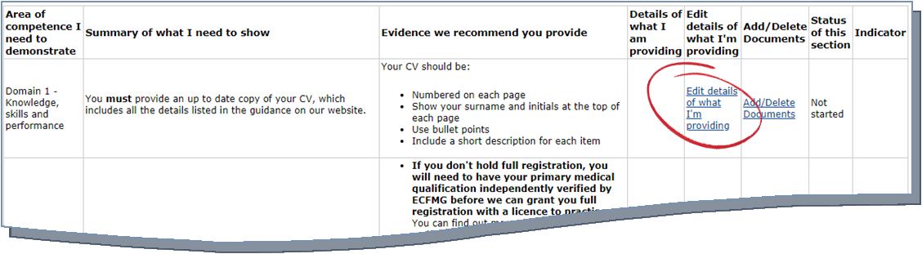
- Click ‘Edit details of what I’m providing’ in the relevant evidence section, as outlined below
- This will then take you to the description of evidence page. This page provides details on what you need to show for this section, the evidence we recommend you provide, and also a description of the statuses for this section
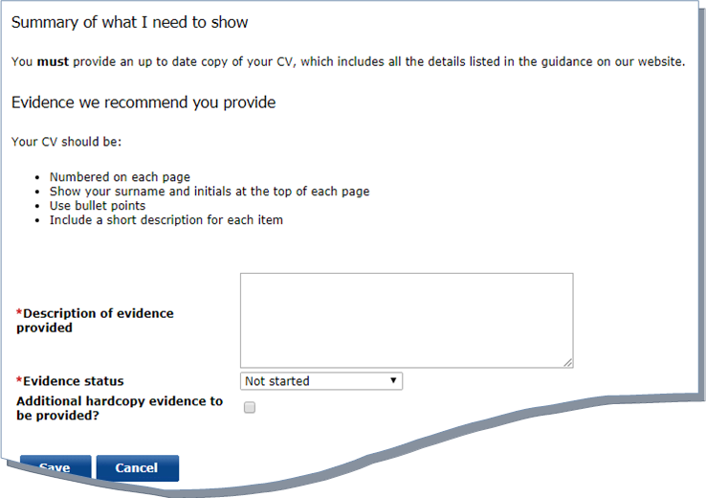
- You’ll need to enter a description of the evidence you’re providing for this section in the text box. You should be as descriptive as possible – for further guidance, please refer to Annex 3
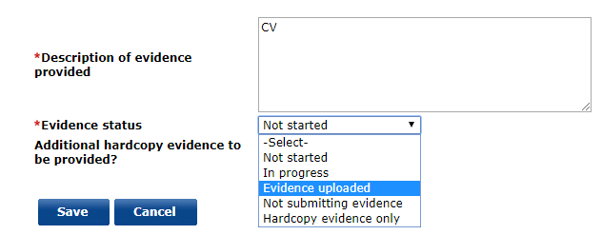
- Once you’ve entered a description, you’ll need to select the relevant evidence status from the dropdown list

- If you’re providing any hard copy evidence for a section, you must ensure that you tick the ‘Additional hardcopy evidence…’ box
- If you intend to only supply hardcopy evidence for a particular section, you must ensure that the status reflects this

- Once you’ve provided a description and selected the relevant status, you’ll need to click ‘Save’. This will take you back to the main evidence summary page
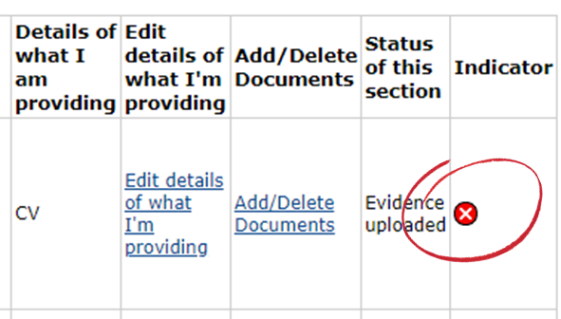
- You’ll note that the indicator tab for the evidence section you’ve provided details for will show a red cross.
To complete this evidence section, follow the remaining steps below…
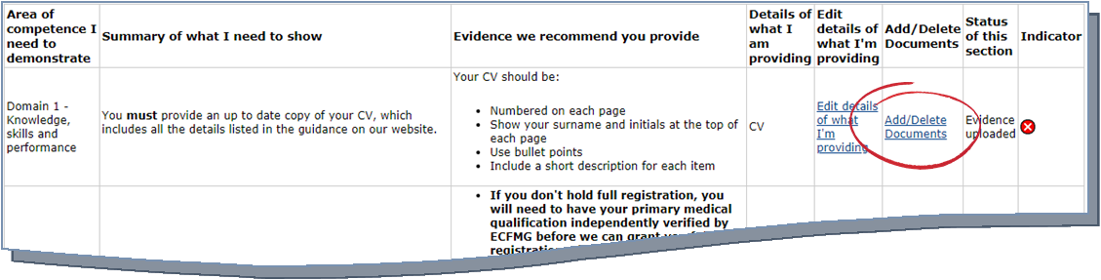
- To upload the electronic evidence, select the ‘Add/Delete Documents’ option for the relevant evidence section on the table
- This will take you to the document upload page. This page provides guidance on uploading evidence, plus what you’re required to show for the particular evidence section and the evidence we recommend you provide

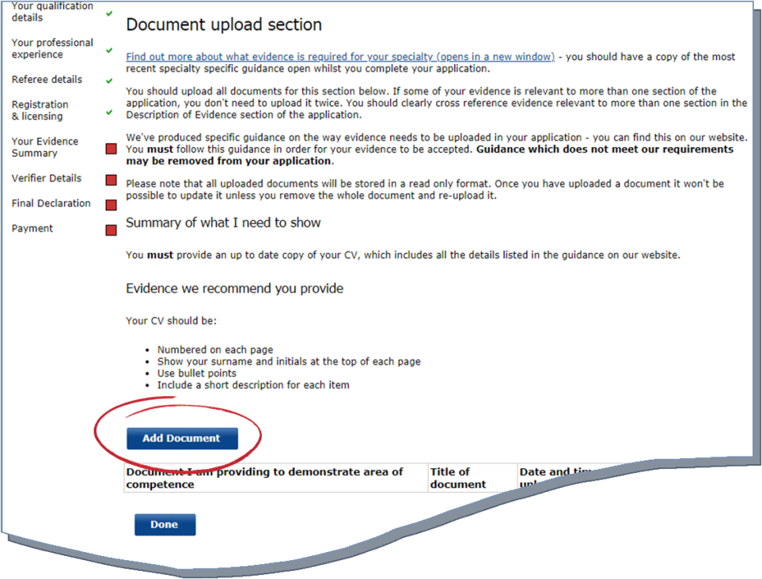
- To add your electronic evidence, select the ‘Add Document’ button
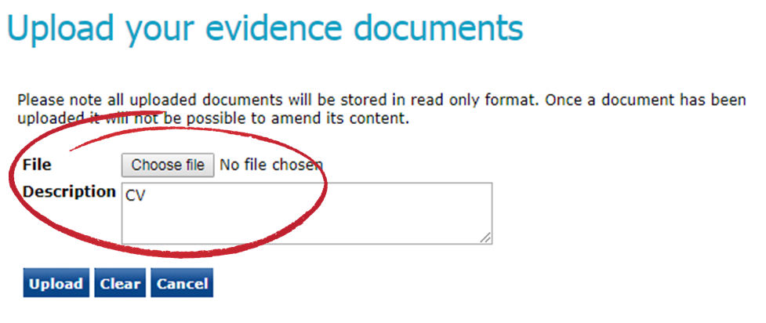
- This will take you to a page where you can upload the relevant document. You’ll need to select the ‘Choose file / Browse’ button and add a brief description of the document you’re uploading
Note: There’s the option to remove a document before submitting the overall application. You should ensure that you’ve uploaded the correct documents before submitting your application.
Important: The name of the file you’re uploading cannot include any of the following characters:
\ / : * ? “< > |
If you upload a document with one of the above characters in the title of the document, we will not be able to view this in your application. Please ensure none of the file names of your documents include the above before uploading these in the application.
Important: You must not upload any documents which are password protected
- You can add as many documents as necessary for each section. Once you’ve finished uploading documents for a particular section, click ‘Done’
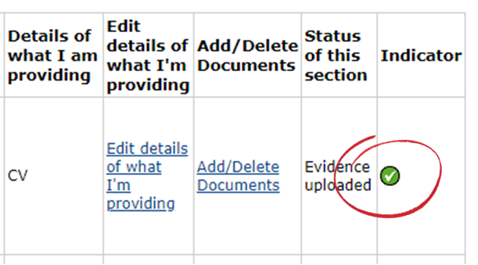
- This will take you to the evidence summary page. You’ll note that the indicator tab for the evidence section you’ve uploaded evidence for will now show a green tick
Complete the rest of the evidence sections following the above points (a-m)
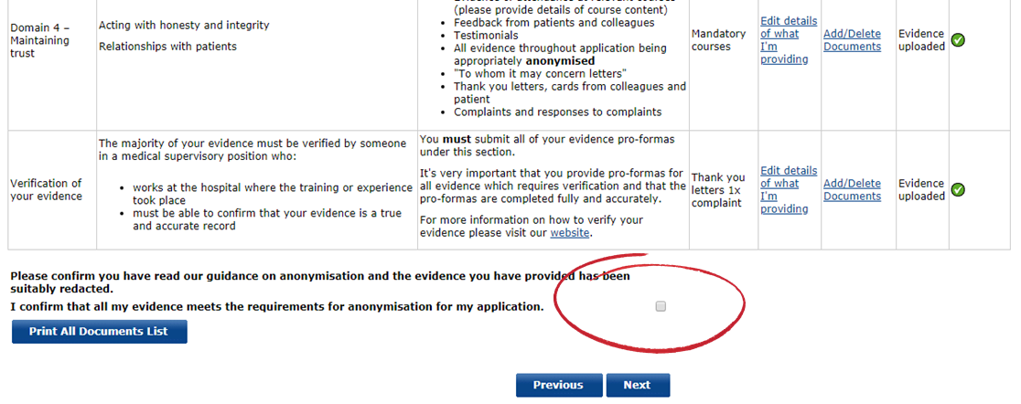
- Once you have added details/evidence for each section, you will need to confirm that you’ve read our guidance on anonymisation and that the uploaded evidence has been redacted.
Note: you’ll be unable to progress your application without ticking this box – any evidence that does not meet our requirements may not be submitted to the Royal College or Faculty for assessment
- Once you’ve completed this page, click ‘Next’

When you’ve added the details of your evidence and uploaded the relevant documents, you have the option to print a list of all your documents. This specifies the area of competence; evidence provided; and date submitted.
This can be used as a personal record of the initial evidence you’ve submitted.
To do this:
- select the ‘Print All Documents List’ button at the top of the evidence summary table

Step 6 – adding details of your verifiers
You must provide the details of a verifier for each hospital or institution that you are providing evidence from.
For further details on verifying your evidence and selecting verifiers, please refer to our guidance.
- To add a verifier, select ‘Add verifier’
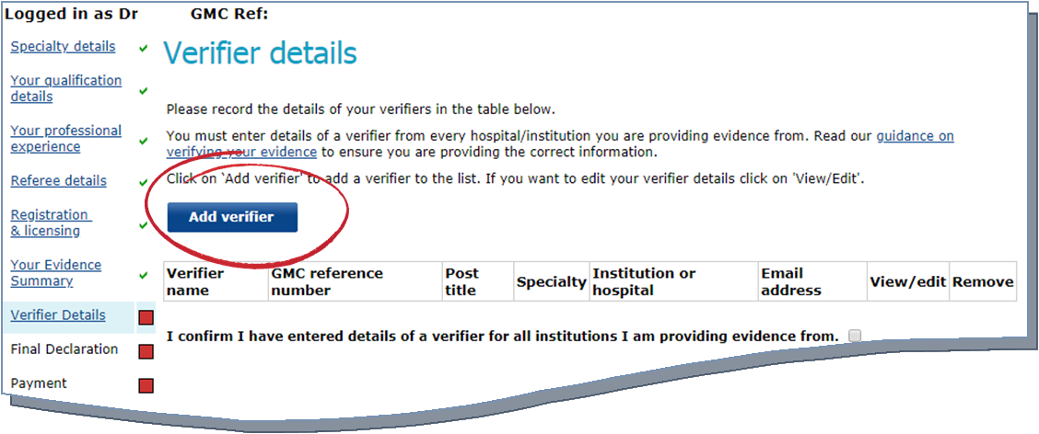
- This will take you to a screen where you will need to enter the details of your nominated verifier. Please note that each field on this screen must be completed.
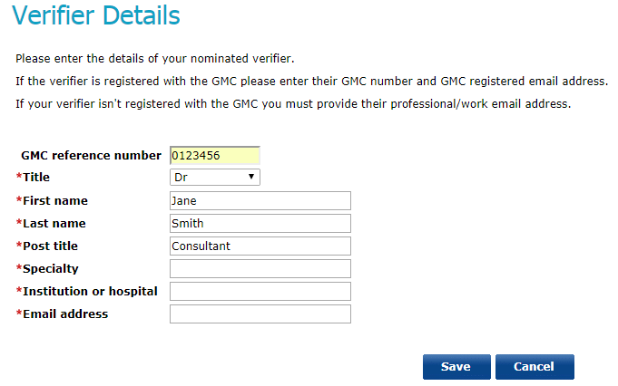

Note: if your verifier has GMC registration, you must provide their GMC reference number
- After adding the verifier details, click ‘Save’ – this will then take you back to the previous screen where you can continue to add the details of your verifiers.
If you want to edit an entry after recording it, select the ‘View/Edit’ option next to each entry
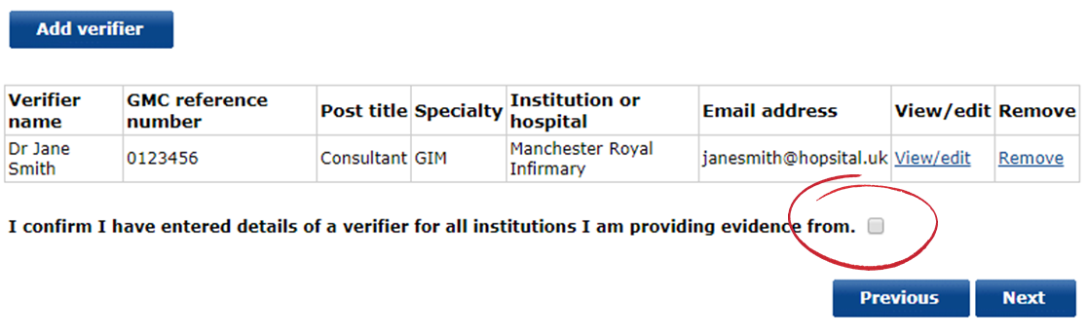
- Once you have added the details of all of your nominate verifiers, you must confirm that you have provided the details of a verifier for all institutions that you are providing evidence from. You can do this by ticking the declaration box as shown below
- Once you have added the details of your verifiers, click ‘Next’

Step 7 – Final declaration and payment
- Once you have completed all sections of the application, you’ll be asked to agree to a final declaration, confirming that the information provided in your application is true and correct.
In order to proceed to payment, you will need to check the tick box
- To make the payment for your CESR/CEGPR application, follow the instructions on the payment pages. Further information regarding specialist/GP application fees can be found here
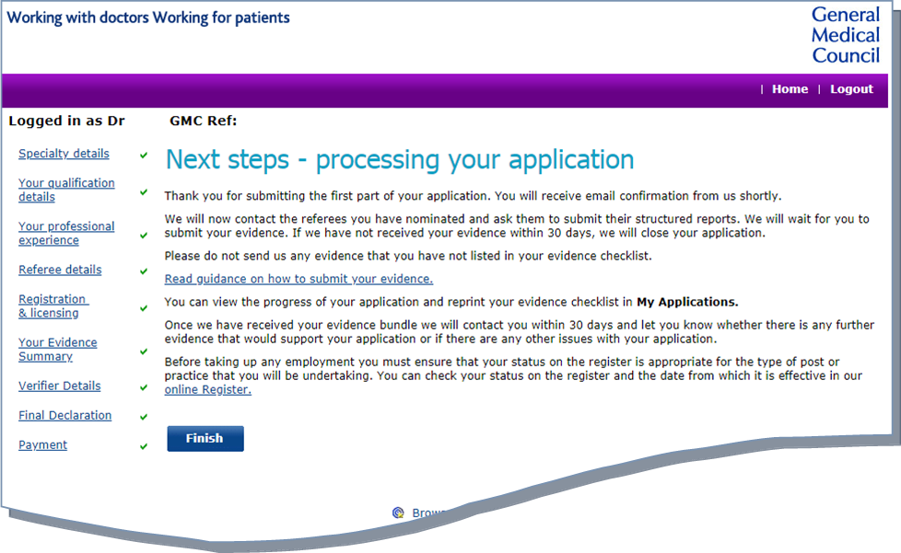
- Upon receipt of the payment, you’ll be taken to a page setting out the next steps for processing your application; you will receive further confirmation via email

Submitting additional evidence
Once an Adviser on the Specialist Applications Team has reviewed your initial documentary evidence, they will provide you with information on:
- What evidence they’ve accepted
- What evidence they’re unable to accept (including the reasons for this)
- Advice and guidance on how your application could be strengthened
You’ll have up to 60 days to provide additional documentary evidence in support of your CESR/CEGPR application.

Step 1 – viewing the Adviser’s comments
To view the comments that the Applications Adviser has made on your documentary evidence, please follow the below steps
- You’ll receive an email (to your GMC registered email address) informing you that the review of your initial CESR/CEGPR evidence has been completed. This will invite you to log on to your GMC Online account to view the comments
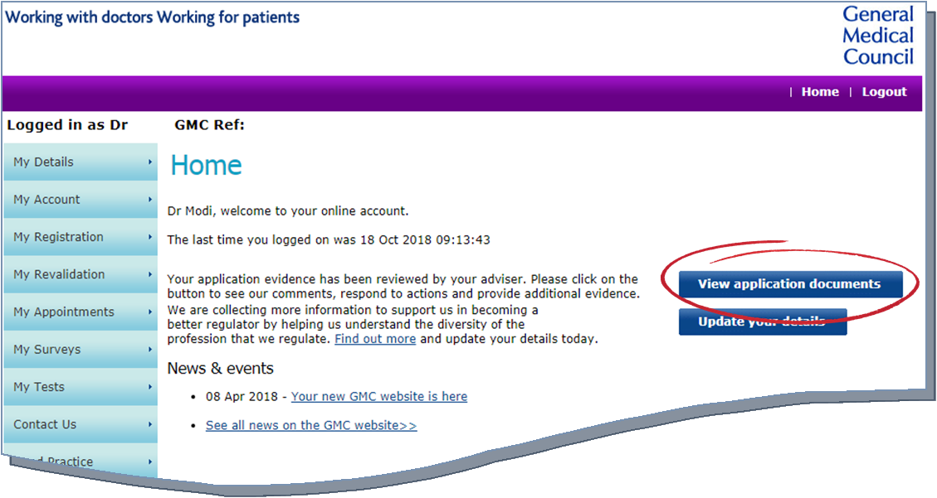
- On your GMC Online account homepage there will be a ‘View application documents’ button. Clicking on to this will allow you to see the Adviser’s comments on the ‘My Documents Summary’ page
You can also view the Adviser’s comments by
- Clicking onto the ‘My Registration’ tab on the left side of your GMC Online homepage
- This will bring up a list of further options, including ‘My Documents’
- Clicking this will allow you to see the Adviser’s comments on the
‘My Documents Summary’ page

- Once on the ‘My Documents Summary’ page, the Adviser’s comments will be listed by:
  - Area of competence – evidence not accepted
  - Area of competence – evidence accepted
Note: the comments provided by the Adviser are read only; you will not be able to edit the Adviser comments.
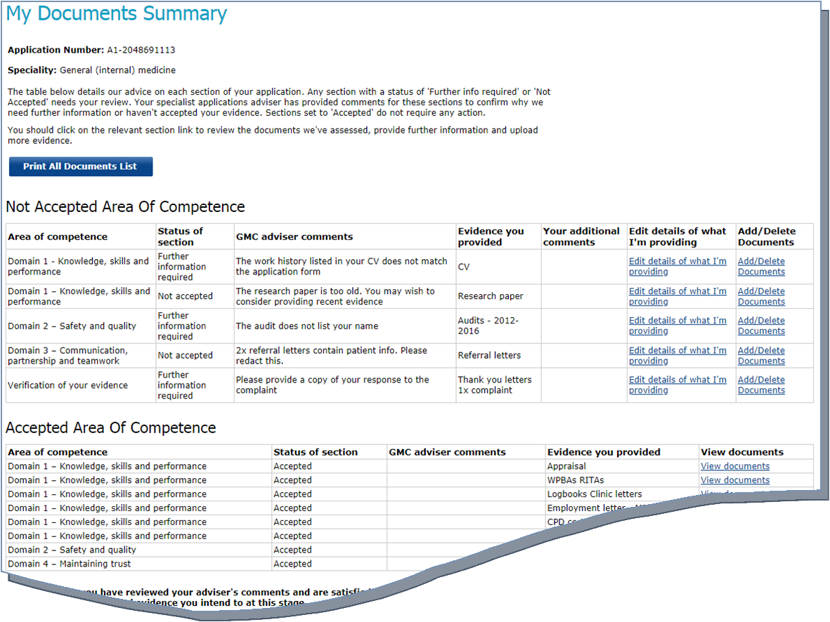

- The Adviser will select a relevant status for each area of the application:
  - Accepted – all evidence submitted for this area has been accepted
  - Further information required – the Adviser has suggested ways that this area could be strengthened
  - Not accepted – evidence in this area has not been accepted
- To view the Adviser’s comments for each individual document in more detail, click onto the ‘Add/Delete Documents’ for each section that has been listed under the ‘Not Accepted’ table
- You have the option to remove documents with the status of ‘Not Accepted’. For example, if the Adviser suggests that the document isn’t relevant (i.e. it’s too old) you can remove it from your application
Any evidence that has not been adequately anonymised and contains patient information will be removed from the online application by the Adviser.
They will notify you of this in their comments; you will need to take action by redacting the information and resubmitting the document.
- If you want to respond to the Adviser’s comments you will need to go back to ‘My Documents Summary’ and click ‘Edit details of what I’m providing’ for those sections with a status of ‘Not Accepted’. You should also use this area to detail the additional or amended evidence that you’re providing for this section.

Step 2 – submitting additional evidence
Once the Adviser has reviewed your initial evidence – and you have reviewed their comments – you have the option to submit additional evidence to support your application. To do this, you should follow the below steps:
- You can submit additional evidence via the ‘My Documents Summary’ page of your application (refer to step 1, points a-b on how to access this)
Note: you can only submit additional electronic evidence for the areas of competence that have not been accepted
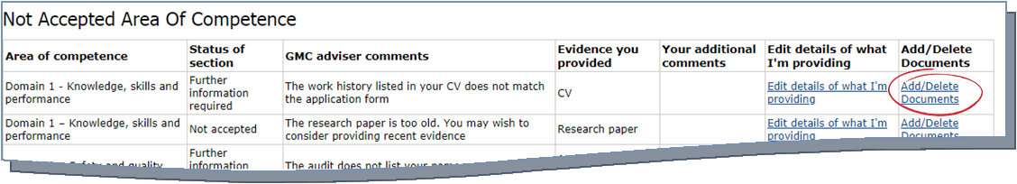
- To submit a new electronic document, click the ‘Add/Delete Documents’ button next to the relevant area of competence
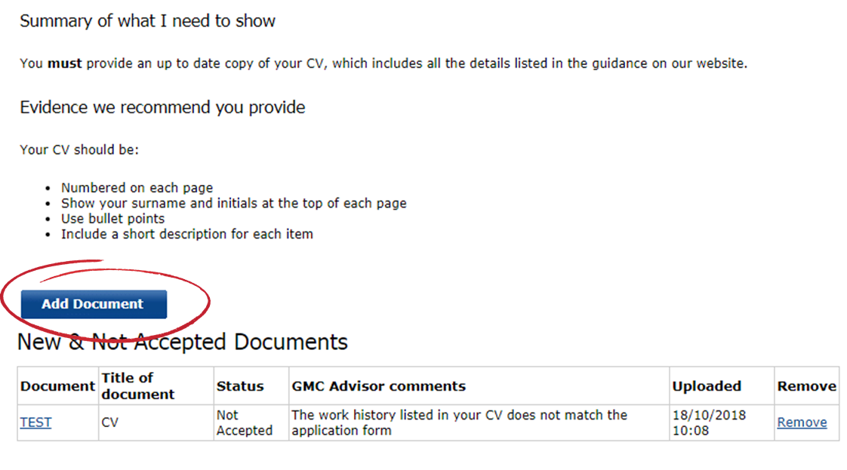
- This will take you to the document upload page, which lists all accepted and not accepted documents.
To add a new document, click ‘Add Document’

- This will take you to a page where you can upload the relevant document. You’ll need to select the ‘Choose file / Browse’ button and add a brief description of the document you’re uploading
- There’s the option to remove a document before submitting the overall application. You should ensure that you’ve uploaded the correct documents before submitting your application.
- You can add as many documents as necessary for each section. Once you’ve finished uploading documents for a particular section, click ‘Done’
- This will take you to the ‘My Documents Summary’ page where you can continue to add further electronic documents using points a-f
- Once you have added details/evidence you’re providing, you will need to confirm that you’ve read our guidance on anonymisation and that the uploaded evidence has been redacted.
Note: you’ll be unable to progress your application without ticking this box – any evidence that does not meet our requirements may not be submitted to the Royal College or Faculty for assessment
Important: The name of the file you’re uploading cannot include any of the following characters:
\ / : * ? “< > |
If you upload a document with one of the above characters in the title of the document, we will not be able to view this in your application. Please ensure none of the file names of your documents include the above before uploading these in the application.
Important: You must not upload any documents which are password protected

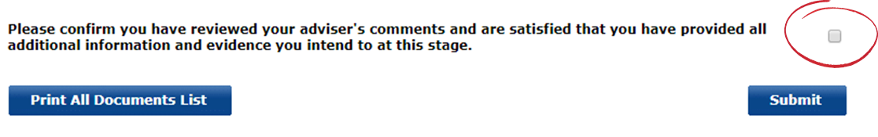

- Once you’ve completed this page, click ‘Submit’
If you would like to submit hardcopy documents for a particular area of competence (that has the status of ‘Further information…’ or ‘Not accepted’), you will need to follow the below steps:
- Click onto the ‘Edit details of what I’m providing’ for the relevant area
- You’ll need to add a description in the free text field outlining the evidence that you’re submitting in hardcopy
- Click ‘Save’
- Once you are satisfied that you have provided sufficient evidence for the areas flagged up by the Adviser (either electronically or in hardcopy), click ‘Submit’

CESR/CEGPR Review applications
If you have recently received an unsuccessful decision for your CESR/CEGPR application, you will have the option to apply for a Review.
For this application you are only required to provide evidence to demonstrate that you’ve met the recommendations provided by the Royal College or Faculty in your initial CESR/CEGPR evaluation form. Further information on applying for a review can be found here.
Review applicants are now able to submit their evidence electronically. To do so, please follow the below steps.

Making a Review application

Step 1 – applying for a Review via GMC Online
- To apply for a Review, you’ll need to log on to your GMC Online account and navigate to the ‘My Registration’ tab on the left side of the screen. This will bring up a list of three options; you’ll need to select ‘My Applications’
- This will bring up a list of all of your previous applications – you’ll need to select the ‘Apply’ button at the top of the list
- You’ll be prompted to read important information and guidance before opening an application; once you’ve read this click the ‘Continue with application’ button
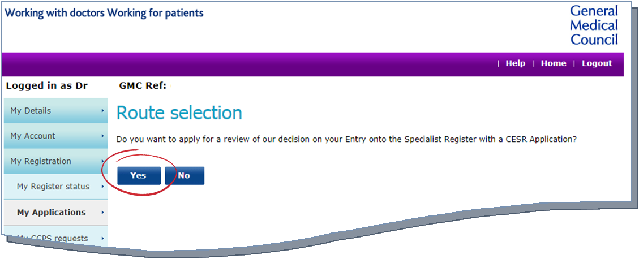
- You will then be asked whether you want to apply for a review of the GMC’s decision regarding your entry onto the Specialist or GP Register (with a CESR/CEGPR application). you should select ‘Yes’
- This will take you to a page outlining the applications you can make; this should provide you with one option: Review of your application for Specialist or GP Registration.
If you want to make a Review application, you should click the ‘Apply’ button

Step 2 – submitting electronic evidence
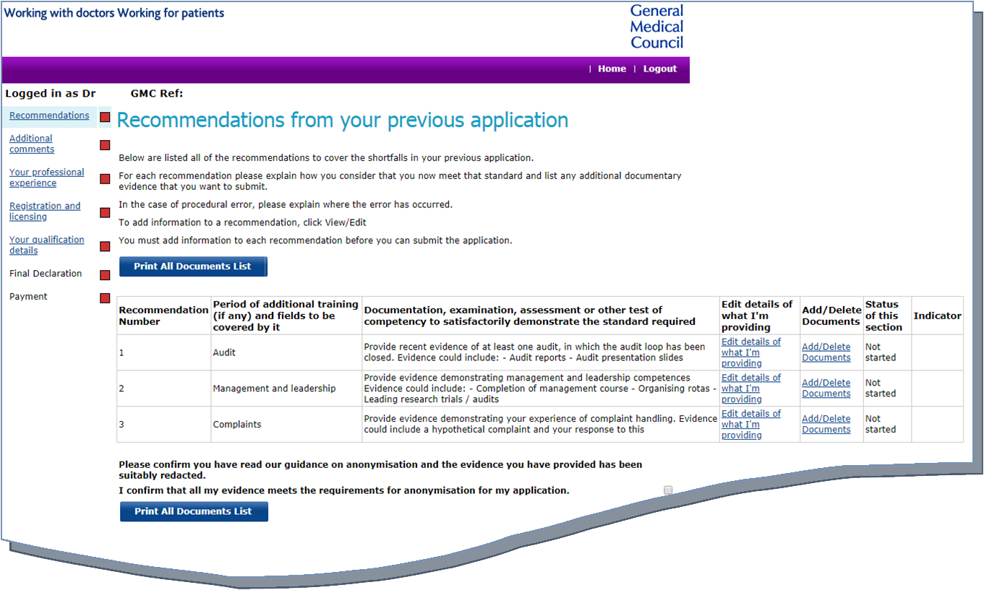
Once you have clicked ‘Apply’, you’ll be taken to the Recommendations page. This outlines the recommendations from your unsuccessful CESR/CEGPR application and provides you with the opportunity to upload electronic evidence to support these recommendations.
To upload evidence, follow the below steps:
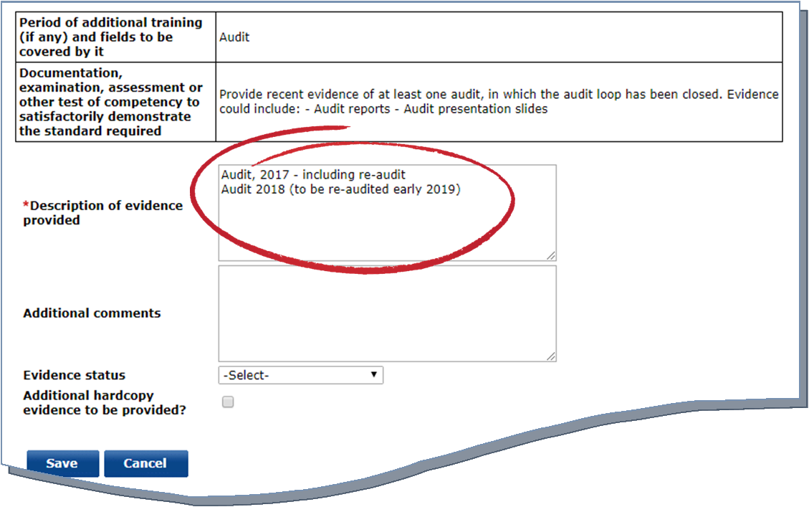
- Click ‘Edit details of what I’m providing’ for the recommendation. This will outline the recommendation; you’ll need to provide a brief description of the evidence you’re providing in the free text field.
Note: there’s the option to provide any additional comments regarding the recommendation in the free text field below – for example, if you feel there has been a procedural error on our part
- Once you have entered a description, you will need to select the relevant evidence status from the dropdown list. Please refer to Annex 1 for further information.
You must also ensure that you’ve provided an appropriate description for each document you’ve uploaded. Please refer to Annex 3 for further guidance
- If you’re any hardcopy evidence for a particular section, you must ensure that you tick the ‘Additional hardcopy evidence…’ box
- If you intend to only supply hardcopy evidence for a particular section, you must ensure that the status reflects this

- Once you have provided a description and selected the relevant status, you will need to click ‘Save’. This will take you back to the main evidence summary page
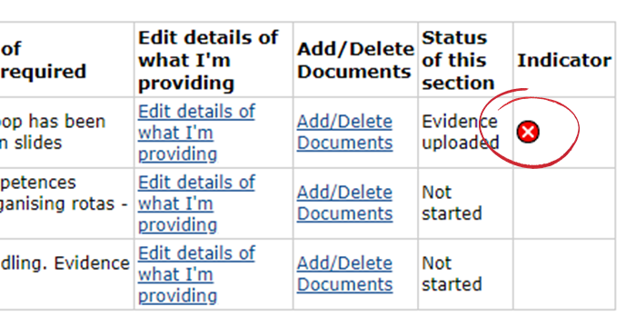
- You will note that the indicator tab for the evidence section you’ve provided details for will show a red cross. To complete this evidence section, follow the remaining steps below
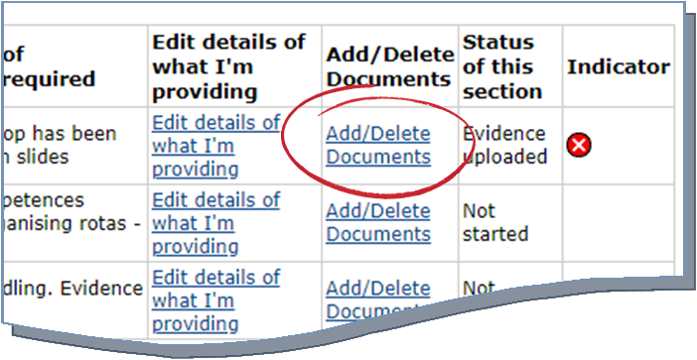
- To upload the electronic evidence select the ‘Add/Delete Documents’ option for the relevant recommendation
- This will take you to the ‘document upload’ page – this page provides guidance on uploading evidence, plus what you are required to show for the particular recommendation.
Click ‘Add Document’
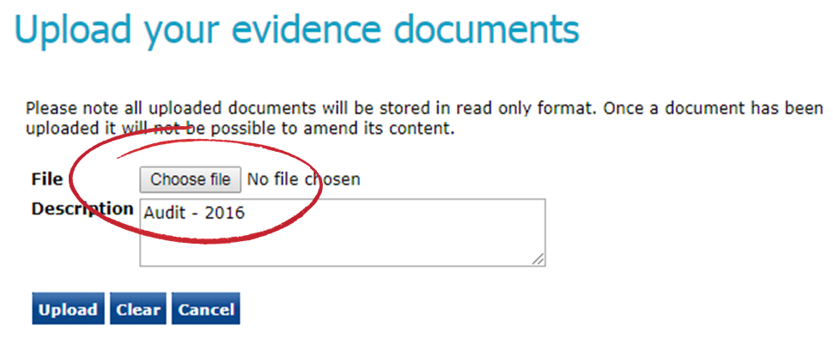
- You will need to select the ‘Choose file / Browse’ button and add a brief description of the document you’re uploading
Note: There’s the option to remove a document before submitting the overall application. You should ensure that you’ve uploaded the correct documents before submitting your application.
Important: The name of the file you’re uploading cannot include any of the following characters:
\ / : * ? “< > |
If you upload a document with one of the above characters in the title of the document, we will not be able to view this in your application. Please ensure none of the file names of your documents include the above before uploading these in the application.
Important: You must not upload any documents which are password protected
- You can add as many documents as necessary for each section. Once you’ve finished uploading documents for a particular section, click ‘Done’
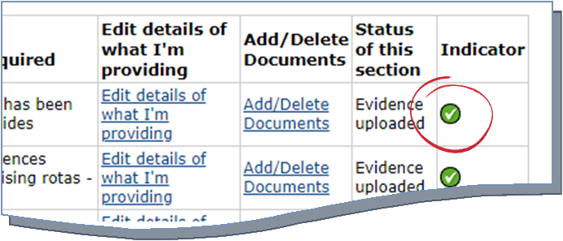
- This will take you to the main recommendation page. You will note that the indicator tab for the recommendation you’ve uploaded evidence for will now show a green tick

- Once you have added details/evidence for each recommendation, you will need to confirm that you’ve read our guidance on anonymisation and that the uploaded evidence has been redacted.
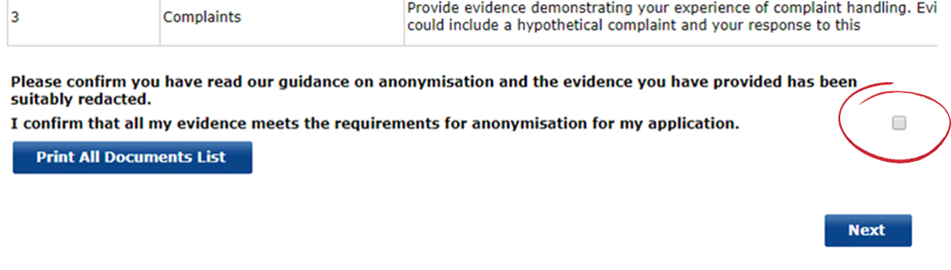
Note: you’ll be unable to progress your application without ticking this box – any evidence that does not meet our requirements may not be submitted to the Royal College or Faculty for assessment
- Once you have completed this page, click ‘Next’
When you’ve added the details of your evidence and uploaded the relevant documents, you have the option to print a list of all your documents. This specifies the area of competence; evidence provided; and date submitted.
This can be used as a personal record of the initial evidence you’ve submitted.
To do this:
- select the ‘Print All Documents List’ button at the top of the evidence summary table

Step 3 – completing the remainder of the online application

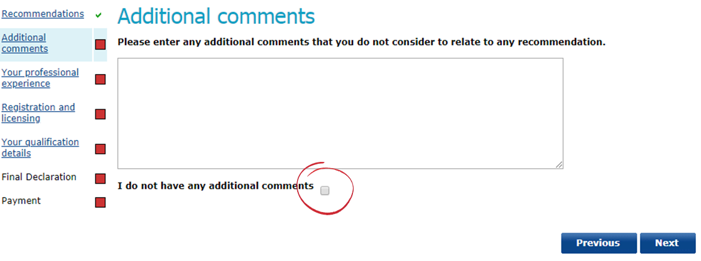
- After uploading your documentary evidence in support of your Review application, you have the option to provide any additional comments. If you do not wish to make any further comments, select the tick box as highlighted below
Click ‘Next’
- You will need to enter the details of your work history (professional experience). You should provide details of all posts you’ve held since your last application
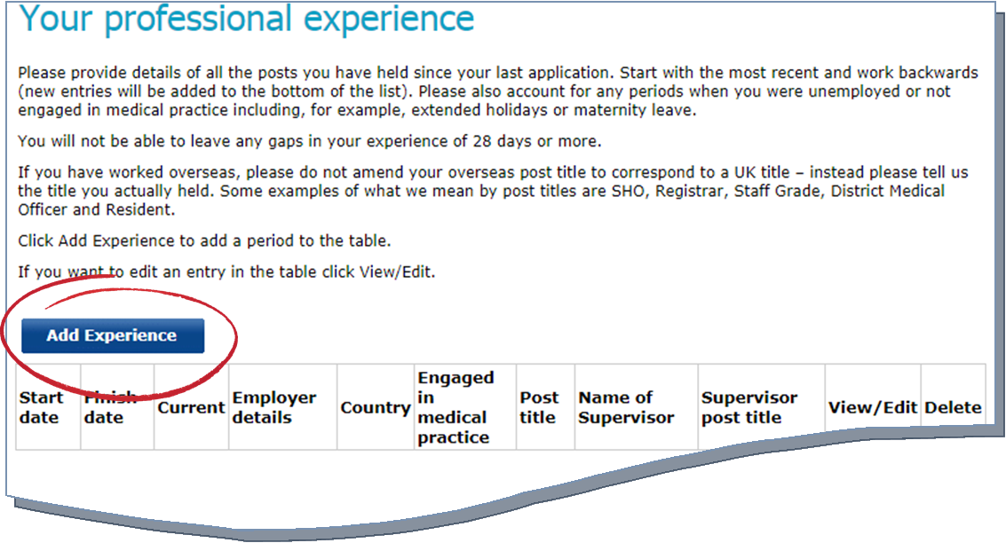
- To add details of your work history, you will need to click ‘Add Experience’, as highlighted below
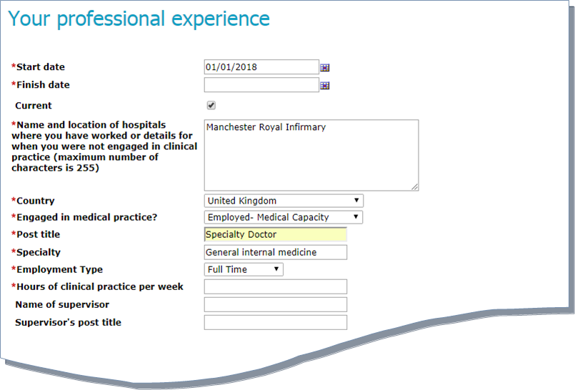
- This will then take you to a screen where you will need to enter the details of each individual post you have undertaken. Please note that each field on this screen must be completed.
After adding the post details, click ‘Save’ – this will then take you back to the previous screen where you can continue to record your professional experience.
If you want to edit an entry after recording it, select the ‘View/Edit’ option next to each entry
- Once you have added your work history, click ‘Next’
- You will need to add the details of all medical regulatory authorities that you have held registration with in the last five years
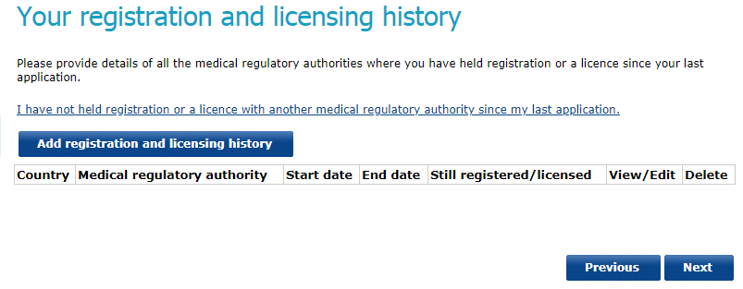
- To add details of your registration and licensing history, click the ‘Add registration…’ button.
This will take you to a screen where you will need to enter the details of your registration/licensing history. Please note that each field on this screen must be completed.
Note: if you have not held registration or a licence with another medical regulatory authority since your last application, you do not need to provide any information. You should click the hyperlink as highlighted above
- By clicking ‘Next’, you’ll be taken to the qualification details screen – you only need to add the details of any relevant qualifications you have obtained since your last application.
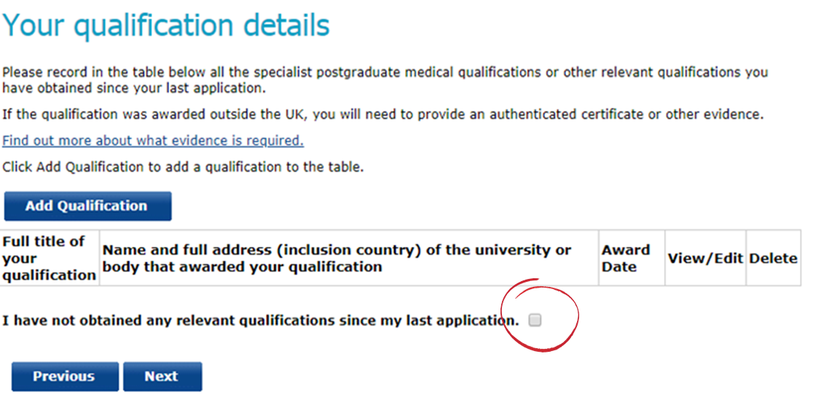
If you have not obtained any relevant qualifications in the last 12 months, you should check the tick box.
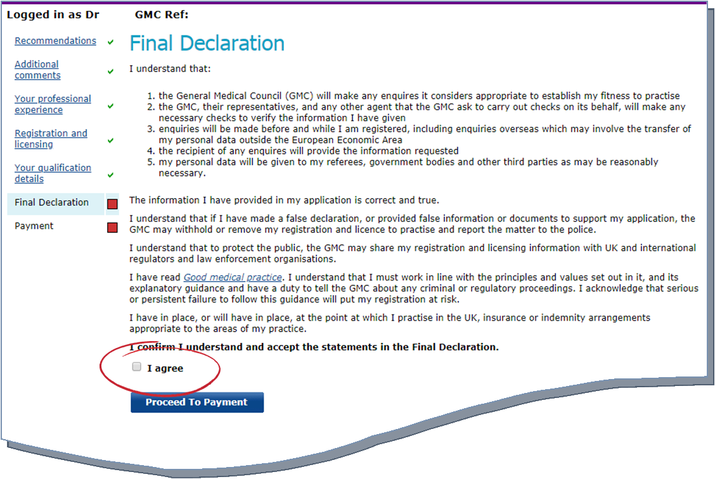
- Once you have completed all sections of the application, you will be asked to agree to a final declaration, confirming that the information provided in your application is true and correct. In order to proceed to payment, you will need to check the tick box
- To make the payment for your CESR/CEGPR application, follow the instructions on the payment pages. Further information regarding specialist/GP application fees can be found here
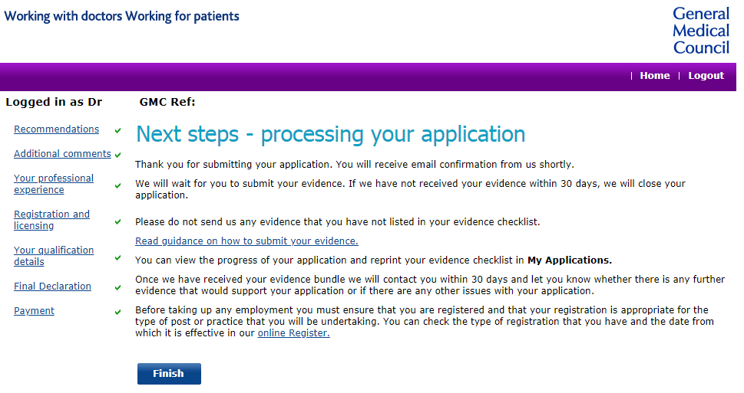
- Upon receipt of the payment, you’ll be taken to a page setting out the next steps for processing your application; you will receive further confirmation via email

Review applications: providing additional evidence
Once an Adviser on the Specialist Applications Team has reviewed your initial documentary evidence, they will provide you with information on:
- What evidence they’ve accepted
- What evidence they’re unable to accept (including the reasons for this)
- Advice and guidance on how your application could be strengthened
You’ll have up to 30 days to provide additional documentary evidence in support of your CESR/CEGPR application.

Step 1 – viewing the Adviser’s comments
To view the comments that the Applications Adviser has made on your documentary evidence, please follow the below steps
- You’ll receive an email (to your GMC registered email address) informing you that the review of your initial CESR/CEGPR evidence has been completed. This will invite you to log on to your GMC Online account to view the comments
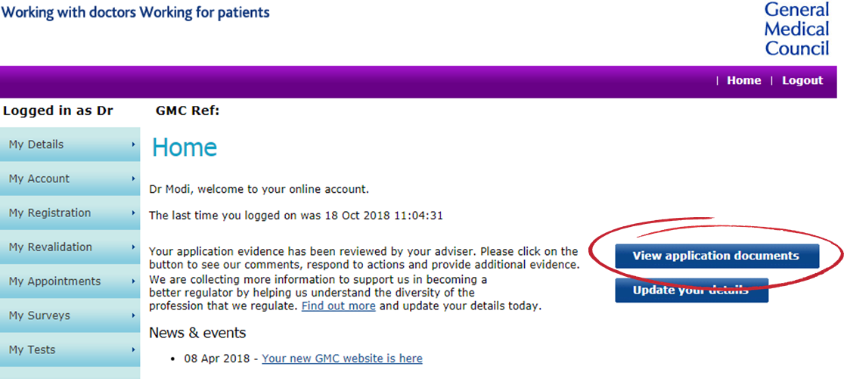
- On your GMC Online account homepage there will be a ‘View application documents’ button. Clicking on to this will allow you to see the Adviser’s comments on the ‘My Documents Summary’ page
- Once on the ‘My Documents Summary’ page, the Adviser’s comments will be listed by:
You can also view the Adviser’s comments by
- Clicking onto the ‘My Registration’ tab on the left side of your GMC Online homepage
- This will bring up a list of further options, including ‘My Documents’
- Clicking this will allow you to see the Adviser’s comments on the
‘My Documents Summary’ page
  - Not Accepted Recommendations
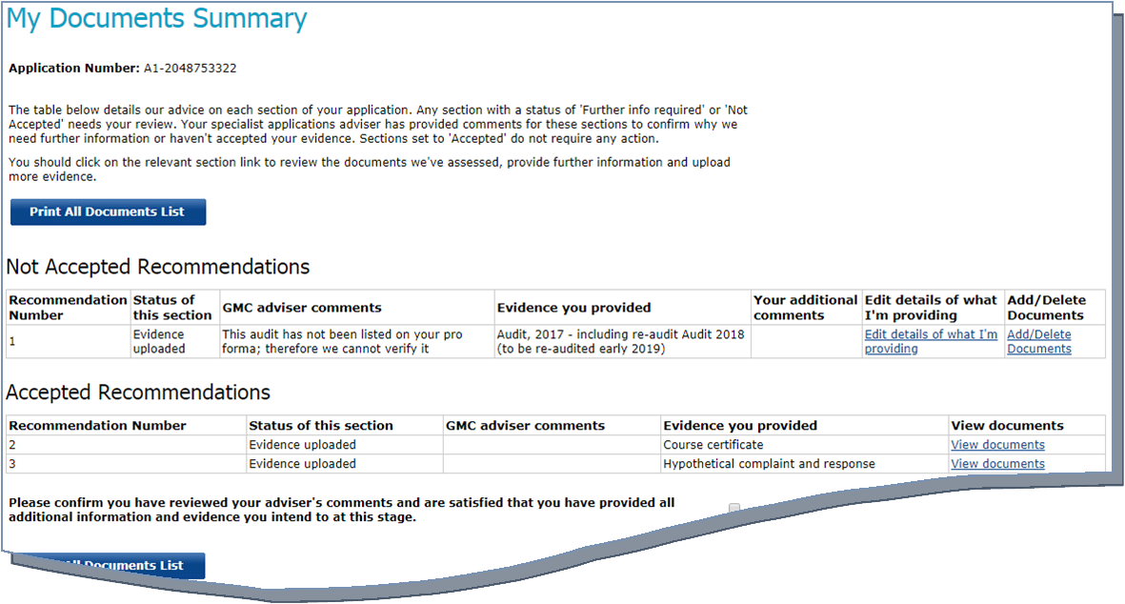
  - Accepted Recommendations
- Next to each area of the application a relevant status will be visible
Note: the comments provided by the Adviser are read only; you will not be able to edit the Adviser comments.
The adviser will select a relevant status for each area of the application:
  - Accepted – all evidence submitted for this area has been accepted
  - Further information required – the Adviser has suggested ways that this area could be strengthened
  - Not accepted – evidence in this area has not been accepted
- To view the Adviser’s comments for each individual document in more detail, click onto the ‘Add/Delete Documents’ for each section that has been listed under the ‘Not Accepted’ table
- You have the option to remove documents with the status of ‘Not Accepted’. For example, if the Adviser suggests that the document isn’t relevant (i.e. it’s too old) you can remove it from your application
- If you want to respond to the Adviser’s comments you will need to go back to ‘My Documents Summary’ and click ‘Edit details of what I’m providing’ for those sections with a status of ‘Not Accepted’. You should also use this area to detail the additional or amended evidence that you’re providing for this section
- To respond to the Adviser’s comments, go back to ‘My Documents Summary’ and click ‘Edit details of what I’m providing’ for each section which hasn’t been accepted
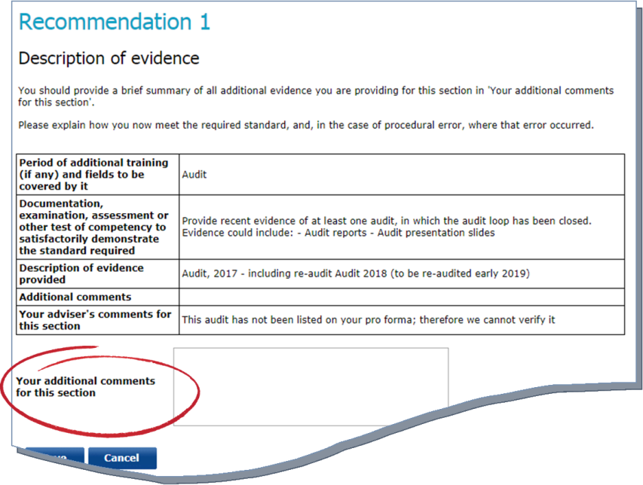
- On this page you have the option to respond to the Adviser’s comments and list any additional evidence you’re submitting
Note: you must add something into the free text field; even if you’re not submitting additional evidence
Step 2 – submitting additional evidence
Once the Adviser has reviewed your evidence – and you have reviewed their comments – you have the option to submit additional evidence to support your application. To do this, you should follow the below steps:
- You can submit additional evidence via the ‘My Documents Summary’ page of your application (refer to step 1, points a-b on how to access this)
Note: you can only submit additional electronic evidence for the areas of competence that have not been accepted
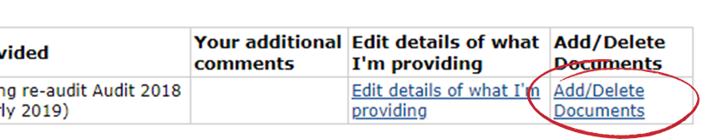
- To submit a new electronic document, click the ‘Add/Delete Documents’ button next to the relevant area of competence
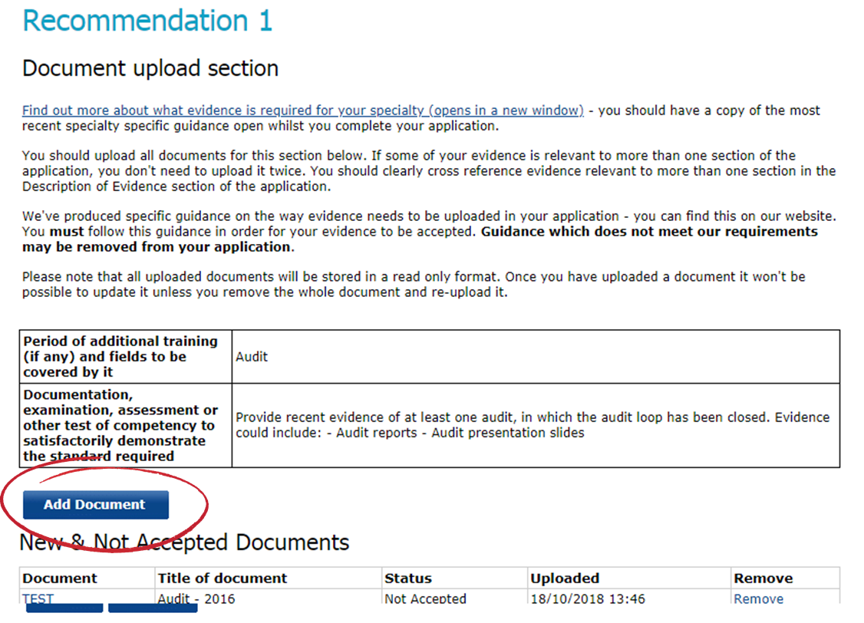
- This will take you to the document upload page, which lists all accepted and not accepted documents.
To add a new document, click ‘Add Document’

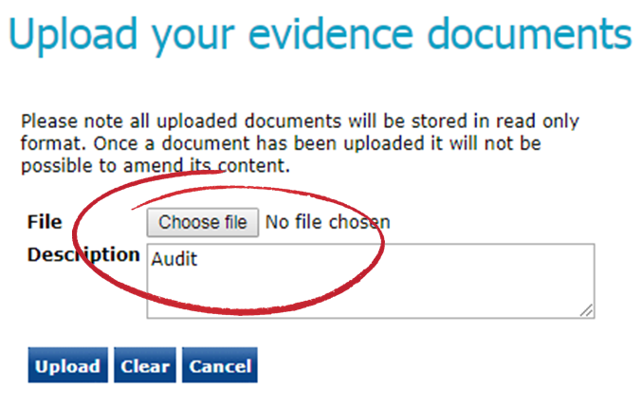
- This will take you to a page where you can upload the relevant document. You’ll need to select the ‘Choose file / Browse’ button and add a brief description of the document you’re uploading
Important: The name of the file you’re uploading cannot include any of the following characters:
\ / : * ? “< > |
If you upload a document with one of the above characters in the title of the document, we will not be able to view this in your application. Please ensure none of the file names of your documents include the above before uploading these in the application.
Important: You must not upload any documents which are password protected
- There’s the option to remove a document before submitting the overall application. You should ensure that you’ve uploaded the correct documents before submitting your application.
- You can add as many documents as necessary for each recommendation. Once you’ve finished uploading documents for a particular section, click ‘Done’
- This will take you to the ‘My Documents Summary’ page where you can continue to add further electronic documents using points a-f
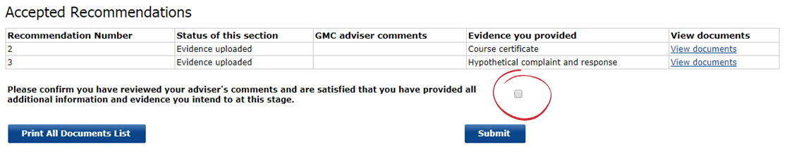
- Once you have added details/evidence you’re providing, you will need to confirm that you’ve read our guidance on anonymisation and that the uploaded evidence has been redacted.
Note: you’ll be unable to progress your application without ticking this box – any evidence that does not meet our requirements may not be submitted to the Royal College or Faculty for assessment
- Once you’ve completed this page, click ‘Submit’

If you would like to submit hardcopy documents for a particular area of competence (that has the status of ‘Further information…’ or ‘Not accepted’), you will need to follow the below steps:
- Click onto the ‘Edit details of what I’m providing’ for the relevant area
- You’ll need to add a description in the free text field outlining the evidence that you’re submitting in hardcopy
- Click ‘Save’
- Once you are satisfied that you have provided sufficient evidence for the areas flagged up by the Adviser (either electronically or in hardcopy), click ‘Submit’

What can I upload?
It’s important that you provide a range of documentary evidence for each area of the CESR/CEGPR application.
Through the online application, you can upload the following electronic files:
- .doc
- .jpg
- .pdf
- .ppt
- .xls

All documents that you upload will be stored in a read only format. Once you upload a document it won’t be possible to update it unless you remove the whole document and re-upload it

Handy hints for your CESR/CEGPR application
Our website contains lots of guidance to help you with your CESR/CEGPR application – a list of useful links can be found in the index.
Our Applications Advisers have produced a list of their top tips for CESR/CEGPR applicants:
- Verification of evidence – it’s important that your evidence meets these requirements. If it hasn’t been verified, it won’t be seen by the Royal College or Faculty. Further guidance on verification can be found here
- Ensure you submit evidence of your eligibility – this should be either a specialist medical qualification or an employment letter detailing the specialist medical training that makes you eligible
- Familiarise yourself with the curriculum – this is what your application will be assessed against; it’s vital that you can demonstrate your equivalence to this in full
- Read the specialty specific guidance (SSG) for the specialty you’re applying in – the online application gives a brief overview of what’s required for each area of the application; the SSG goes into much more detail
- Make sure your evidence is anonymised – any evidence that doesn’t meet anonymisation requirements won’t be seen by the Royal College or Faculty
- Don’t apply too early – make sure you’ve got your evidence ready before you submit your application
- Gather your evidence prospectively where you can
- Make sure your CV meets our guidance; and your employment history matches your CV
- Don’t duplicate evidence – you should cross reference instead
- Listen to your adviser – they are experts in processing these applications

Contacting us

We’re happy to help guide you through the online application or provide further advice on the requirements for CESR/CEGPR applications
You can contact us by
Email
equivalence@gmc-uk.org

Phone
0161 923 6602


Annex 1 – Evidence statuses

- Not started – this is the default status and indicates that you have not yet started an evidence section
- In progress – whilst you collate the evidence for your application, you can select this status. This allows you to keep track of which sections of the application you’ll need to revisit
- Evidence uploaded – if you’re providing electronic evidence for a particular section, you should select this status. If you’re providing a mixture of hardcopy and electronic evidence for a particular section, select this status and tick the box to confirm that additional hardcopy evidence will be provided
- Not submitting evidence – if you’re not providing any evidence for a particular section, you should select this status and provide details of why you aren’t providing evidence
- Hardcopy evidence only – if you’re only providing hardcopy evidence for a particular section, select this status

Annex 2 – Troubleshooting

We understand that from time to time, online applications can be tricky to navigate and errors sometimes occur.
We’ve put together a useful guide to help you if you encounter any errors when you’re completing your online application.

Referee details page
“Please add at least one referee or tick the option stating you do not wish to provide referees”
- You must enter the details of at least one nominated referee in order to progress your application

Evidence summary page
“You are unable to submit your application until you have completed all sections, including the overall status of each section. Please review the sections with a red indicator to ensure all sections are completed in full”
- This will show up if one or more sections of the evidence summary table haven’t been completed
“You are unable to submit your application until you have read and confirmed the declaration. Please confirm the declaration and submit your application”
- You will receive this message if you haven’t ticked the declaration box at the bottom of the evidence summary page

Description of evidence page
“Please enter a description for the evidence you are providing for this section”
- This message will appear if you’ve not entered a description in the free text field. To progress the application, you’ll need to add an appropriate description. For further guidance please refer to Annex 3
“You are unable to continue to the next stage of your application as you have not entered a reason to confirm why you are not providing evidence for this section. Please enter a reason to continue with your application”
- You’ll receive this message if you’ve selected the ‘not submitting evidence’ status and have ticked the hardcopy evidence box. You’ll need to check that the statuses are correct for this section and provide a description in the free text field

Document upload page
“You must specify a file to upload and add a description”
- This message will occur if you haven’t uploaded a file, but have pressed the ‘upload’ button – or – if no description has been added for the document

“This file isn’t supported”
- You’ll receive this message if you’ve uploaded a file that isn’t supported

Verifier details page
“Please confirm that you have entered details of a verifier for all institutions you are providing evidence from”
- At least one verifier needs to be added when the ‘next’ button is pressed
“You are unable to submit your application until you have provided details of at least one verifier. Please add verifiers using the instructions below”
- At least one verifier needs to be added when the ‘next’ button is pressed and the declaration boxed has been ticked
“Please enter the title of your verifier”
- You must complete all mandatory fields, including your verifier’s title
“The email address you have entered is incorrect. Please ensure you enter a valid email address”
- You must enter a valid email address for each verifier

Resubmitting evidence
“You are unable to submit your application until you have completed all sections, including the overall status of each section. Please review the sections with a red indicator to ensure all sections are completed in full”
- This message will appear if one or more sections haven’t been completed
“You are unable to submit your application until you have read and confirmed the declaration. Please confirm the declaration and submit your application”
- You’ll receive this message if you haven’t ticked the declaration box

Resubmitting evidence – description of evidence page
“Please confirm that you have reviewed your adviser’s comments and are satisfied that you have provided all additional information and evidence you intend to at this stage”
- You’ll need to enter a brief description in the free text field, even if you do not wish to provide any further evidence

Annex 3 – Documentary evidence
Below you’ll find a table outlining which types of evidence you can upload electronically and an example of the description you could provide for each evidence type. You need to be as descriptive as possible for each document that you’re uploading.
It may be appropriate to group evidence together into one document before uploading your evidence rather than uploading each piece of evidence individually.
We suggest no more than five to ten pieces of evidence which require anonymisation is grouped into a document – although each piece of evidence may contain more than one page. This is because if one piece of evidence has not been anonymised all the other evidence in the uploaded document will also be deleted from your application and need to be resubmitted.
Please avoid uploading blank pages within your documents.
You should also refer to the Specialty Specific Guidance for information on any further specific requirements on presentation of your evidence for the specialty you are applying in which may not be listed below.
All evidence which needs translating will need to be submitted as hard copy in line with our guidance.
You must give an appropriate title to each document you upload electronically. The title of the document must list (unless otherwise suggested below):
- The type of document it is
- The date of the document, or dates the document covers
- The institution the document is from
It’s really important you use the naming conventions and evidence groupings suggested below for evidence you’re uploading electronically – this will help us process your application more quickly.
Note: The name of the file you’re uploading cannot include any of the following characters:
\ / : * ? “< > |
If you upload a document with one of the above characters in the title of the document, we will not be able to view this in your application. Please ensure none of the file names of your documents include the above before uploading these in the application.

Type of evidence I am submitting | How can I upload this evidence? | Can I submit this evidence online? |  | Example of what document should be called
Primary Medical Qualification (PMQ) – application with full registration only | N/A |  | As this evidence needs authenticating this must be submitted as a hard copy | MB BCh Oxford University 1982
Specialist Medical Qualification (SMQ) | Upload each qualification you are providing as a separate document |  | Yes, however if your SMQ is from outside the UK this will need authenticating and must be submitted as a hard copy | MRCP 2012
Curriculum or syllabus | Upload each curriculum you are providing as a separate document |  | Yes, however if your curriculum is from training outside the UK this will need authenticating and must be submitted as a hard copy | Clinical Radiology Specialty Curriculum –Mumbai University Hospitals - 2007
Specialist registration outside the UK | N/A |  | As this evidence needs authenticating this must be submitted as a hard copy | CGS Egyptian Medical Syndicate 2018
Honours and prizes | Group evidence in this section as one bundle |  | Yes | ‘Best presentation’ prize - 2018
Other relevant qualifications and certificates | Upload each qualification or certificate you are providing as a separate document |  | Yes | MSc Clinical Research – University of Manchester 2018
Appraisals | Upload each appraisal you are providing as a separate document |  | Yes | Appraisal 2016 -2017 Stepping Hill Hospital
Assessments/SLEs/WPBAs | Group assessments by year completed and institution. |  | Yes | DOPS – Stepping Hill Hospital - 2015
Ritas, ARCPs and training assessments | Group evidence in this section by year of training |  | Yes | ARCP outcome 1 ST3
360 and multisource feedback | Group evidence in this section as one bundle |  | Yes | 360 feedback 2015-2018
Personal development plan (PDP) | Upload each PDP you are providing as a separate document |  | Yes | PDP 2015 Stepping Hill Hospital
Logbooks | Group your logbooks by date and institution. We suggest you divide these by year. |  | Yes | Logbook 01/01/2017-07/07/2017 Stepping Hill Hospital
Consolidation, cumulative data sheets and statistics | Group evidence in this section by institution |  | Yes | Total procedures 2015-2017 – Stepping Hill Hospital
Medical reports | We suggest you group these by procedure/competence covered and institution, with no more than ten medical reports in one document |  | Yes | 10 Medical reports for acute presentations – Stepping Hill Hospital 2015-2017
Case histories | We suggest you group these by procedure/competence covered and institution, with no more than ten case histories in one document |  | Yes | 10 case histories for acute presentations – Stepping Hill Hospital 2015-2017
Referral letters | We suggest you group these by procedure / competence covered and institution, with no more than 10 letters in one document |  | Yes | 10 referral letters for surgical opinion – Stepping Hill Hospital 2015-2017
Patient lists | Upload as individual documents for each clinic/list per institution |  | Yes | Outpatient clinics list 2015 – Stepping Hill Hospital
Departmental (or trust) workload statistics | Group evidence by institution |  | Yes | Department statistics – Stepping Hill Hospital – 2016-2017
Rotas, timetables and job plans | Group your evidence by institution |  | Yes | On call rota – Stepping Hill Hospital– May – Dec 2017
Courses relevant to the curriculum | Group your evidence in this section as one bundle |  | Yes | Courses relevant to the curriculum – 2015-2017
Employment letters, job descriptions and job plans | Group evidence together by post |  | Yes | Employment letter, contract and job plan – Stepping Hill Hospital – Locum Consultant May 2013- April 2014
Research publications and presentations | Group your evidence relating to each project in one bundle |  | Yes | ‘Study into recovery time post surgery’ – Stepping Hill Hospital - 2015
CPD | Group evidence in this section as one bundle |  | Yes | CPD diary and certificates 2015-2018
Membership of professional bodies and organisations | Group evidence in this section based on the institution or body they relate to |  | Yes | Membership details 2015-2017 BMA
Teaching and training | Group evidence relating to a teaching by institution  If submitting assessments of trainees these should be grouped by year/institution and we suggest no more than 10 assessments per document |  | Yes | Rota, lecture slides and feedback ‘FY1 Induction’ – Stepping Hill – 2017  10 DOPS – Stepping Hill – 2018  FRCS examiner invitation and timetable - 2018
Audit | Group evidence relating to each audit |  | Yes | ‘Audit and re-audit on clinical outcomes 2015-2016’ – Stepping Hill Hospital
Reflective diaries | Group all this evidence in one document |  | Yes
Service improvement and clinical governance | Group evidence relating to annual activity per institution they relate to |  | Yes | MDT attendance and minutes – Stepping Hill Hospital - 2017
Health and Safety | Group evidence in one bundle |  | Yes | Mandatory training – Stepping Hill Hospital- 2018
Communication | Group this evidence by institution. |  | Yes | Communication evidence – Stepping Hill Hospital 2015-2016
Working in Multidisciplinary teams | Group this evidence by activity and institution. |  | Yes | MDT attendance and minutes – Stepping Hill Hospital - 2017
Management and leadership experience | Group this evidence by institution. |  | Yes | Rota management – Stepping Hill Hospital 2016-2017
Chairing meetings and leading projects | Group this evidence by institution |  | Yes | Review of medications prescribed – Stepping Hill Hospital – 2015-2016
Testimonials from colleagues | Group all this evidence by institution |  | Yes | Testimonials from colleagues at Stepping Hill Hospital – 2015-2018
Thank you letters | We suggest you group this evidence with no more than 10 anonymised letters per document |  | Yes | 10 thank you letters – Stepping Hill Hospital – 2015-2018
Complaints | Group this evidence by individual complaint/significant event |  | Yes | Datix complaint – Stepping Hill Hospital - 2018

Index – useful links

- GMC website – www.gmc-uk.org
- CESR/CEGPR application – https://www.gmc-uk.org/registration-and-licensing/join-the-register/registration-applications/cesr-cegpr-application-process
- Specialty curricula – https://www.gmc-uk.org/education/standards-guidance-and-curricula/curricula
- Specialty specific guidance – http://www.gmc-uk.org/doctors/registration_applications/ssg.asp

Please refer to our guidance on CCT specialties and non-CCT specialties
If you’ve submitted a Review application, you’ll have 30 days to provide additional evidence
Subject to meeting the required verification checks – please see our verification guidance for further information
This evidence may not meet the GMC’s evidence requirements – e.g. anonymisation / verification
Subject to meeting the required verification checks – please see our verification guidance for further information
This evidence may not meet the GMC’s evidence requirements – e.g. anonymisation / verification

